|  |
| --- |
| Queensland university of technology |
| INB201 Project |
| Required Documentation |
|  |
| **Peter Burt, Andrew Snodgrass, Michael Moss, Yancie Ng** |
| **30/05/14** |

|  |
| --- |
|  |

Table of Contents

1. Project Overview 2

2. A Statement of Contribution 3

3. Functional Requirements 4

3.1. User Stories 4

3.2. Prototype Layouts 1

3.3. User Requirements 2

3.4. Non-Functional Requirements 3

4. System Documentation / Design Specification 4

5. Database Design 6

6. Code Quality Assurance 8

7. Acceptance Test Plans 9

8. Operations Documentation 10

8.1. Installation instructions 10

8.2. Backup Procedures (Database): 10

9. User Guides 11

9.1. Doctor User Guide 11

9.2. Receptionist User Guide 15

9.3. Administrator User Guide 18

10. Sprint Backlogs, Burn Down Charts 20

10.1. Sprint 1 20

10.2. Sprint 2 21

10.3. Sprint 3 23

10.4. Sprint 4 26

10.5. Sprint 5 28

# 1. Project Overview

The Townsville Children’s Hospital intranet and Patient Record System (PRS) is designed to be a user friendly interface for all employees of the hospital. This includes doctors, nurses, receptionists and administrators. Access to the functionality of the system is controlled by the employee’s role within the hospital, with access being granted according to job title.

The role based access covers day-to-day hospital functionality such as:

* creating new patient and staff records
* searching patient and staff records
* booking appointments
* uploading x-ray scans
* assigning bed numbers to patients
* uploading and reviewing doctor and nurse notes
* checking patient history
* … and other common tasks

All these functions are available via a hospital wide intranet that can be accessed at any computer terminal or mobile device that is connected to the local network. This access is achieved by entering your unique employee user name and password.

The benefits of this system are that it provides centralised databases that are accessible to all hospital employees. Access to this system is controlled according to role based access so users only have access to functions that are required for their roles in the hospital. This allows for the sharing and dissemination of documents relating to patient records, employee records and other day-to-day hospital tasks while maintaining document control and confidentiality.

The risks associated with a centralised repository are reduced by requiring users to enter a user name and password which dictates their access privileges when utilising the Townsville Children’s Hospital intranet.

# 2. A Statement of Contribution

Andrew Snodgrass – Andrew has contributed by designing and creating the initial web pages, collecting the reviewing the functional requirements of the project and putting together the required documentation.

Yancie Ng – Yancie has contributed by redesigning the web pages so they are more functional, attractive, user friendly and comply with common HTML, CSS and JavaScript standards. She has also edited and created PHP code when necessary as new functionality was introduced or changed.

Peter Burt – Peter was primarily in charge of the database design, creation and management. He was also responsible for the creation and maintenance of PHP and JavaScript code. This linked the server-side databases to the client-side intranet and made the data searchable, editable and deletable.

Michael Moss – Michael generated patient data for the twelve relational SQL databases as required. He has also provided technical assistance for team members when issues arose.

# 3. Functional Requirements

The user roles which are covered by the Townsville Children’s Hospital are as follows:

* Doctor
* Receptionist
* Nurse
* Administrator

# 3.1. User Stories



Figure 1 - Doctor Lisa

Doctor Lisa has a busy work and personal life. She wants to be able to upload her patient notes whenever she has access to a computer terminal. She doesn’t want to have any technical problems and expects the design to be user friendly and easy to follow. She wants to review upcoming surgeries, patient medical history and prescriptions. Doctor Lisa also wants to keep a note on patient progress by accessing the latest nurse observations to see if patients are responding to prescriptions, if their symptoms worsen or any other changes occur.



Figure 2 - Receptionist Rachael

Receptionist Rachael has a busy job organising patient records. She has to create, edit and delete records as required and expects this functionality to be available on the Townsville Children’s Hospital intranet. She also books appointments as required, discharges patients, assigns beds and exports patient data in PDF format if they are transferred to another hospital.



Figure 3 - Nurse Jane

Nurse Jane is kept busy seeing to all the patient needs and assists the doctors in surgeries. She checks on patients daily and wants to upload her observations to the Townsville Children’s Hospital intranet. This is so she can share information then with her fellow nurses and support doctors with the decision making process regarding appropriate prescriptions.



Figure 4 - Administrator Henry

Administrator Henry wants to be able to be supported in his job of being a system administrator by being able to create, edit and delete employee records from the Townsville Children’s Hospital intranet. He wants to be able to access records from the server-side databases as easily as possible with a minimum of fuss. He also wants to be able to generate reports to show colleagues and management.

# 3.2. Prototype Layouts

Initial layout of the Townsville Children Hospital intranet:

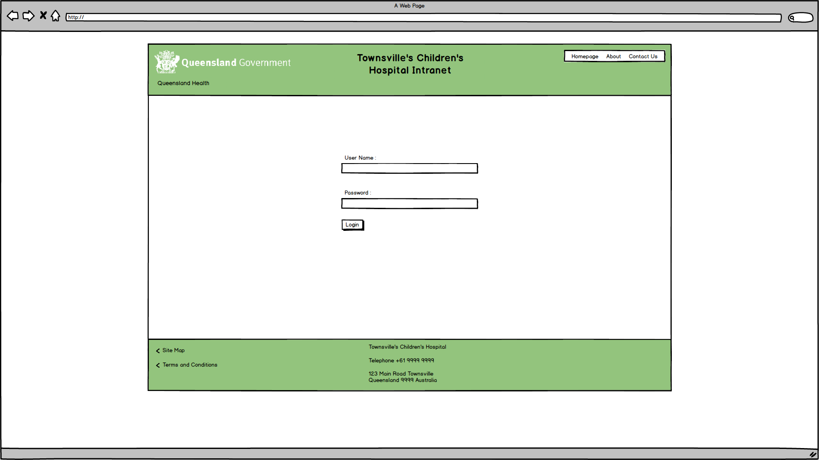

Figure 5 - Login page

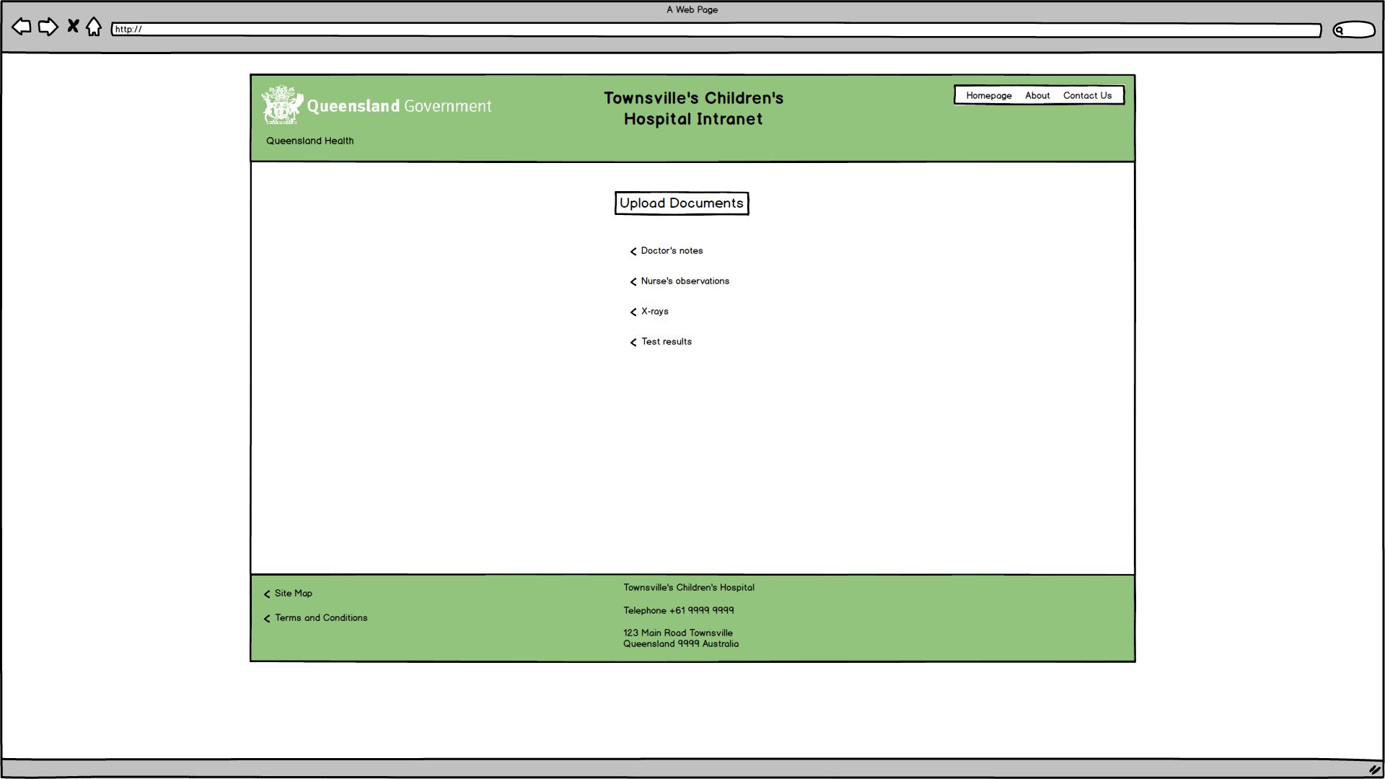

Figure 6 - Upload documents page

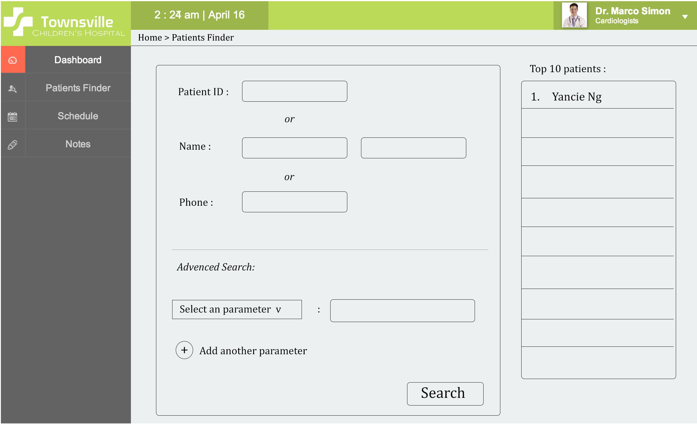

Figure 7 - Refined layout for the patient search page

# 3.3. User Requirements

* Track patents
  + Admission to discharge
  + Consolidate all patent information
    - E.g. Patient history, test results, observations, doctor’s orders, surgeries
* Track financial information
  + Calculating & claiming Medicare rebate or refunds
* Secure access control
  + Staff need to authenticate to access
  + Password based
  + Given privileges
    - Role based
      * Doctor’s notes
      * Nurses observations
      * Test results
        + Jpg files to test
        + From medical technicians
      * Patient information entered by receptionists
      * System admins be able to configure & query the system without having to change the code
* System be able to schedule patient activities & hospital resources
  + Includes:
    - Patient beds
    - Operating theatres
    - MRI
    - X-ray machines
    - Etc…
* Data can be exported to pdf
  + For when patients are transferred to another hospital

# 3.4. Non-Functional Requirements

* User interface is suitable for non-technical users
* Ensure all code is written and formatted according to a source code standard
* System is designed in a proper manner to enable reliability, availability and scalability

# 4. System Documentation / Design Specification

The following is a graphical representation of the system overview. It contains all system elements and technologies. This shows the interaction between components of this system and relationships between them. The server side hospital terminals utilise XAMPP to support the system architecture.

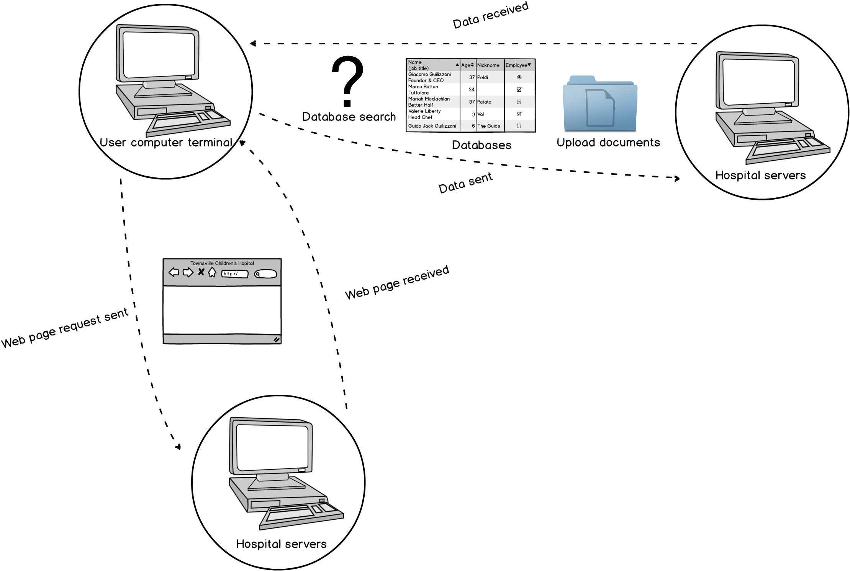

Figure 8 - System overview

Technologies and tools that were used are as follows:

* HTML5
* CSS3
* JavaScript, along with the following libraries:
  + jQuery version 1.11.0 – a widely-used library that makes a lot of complicated JavaScript possible. Available at <http://blog.jquery.com/2011/11/21/jquery-1-7-1-released/>
  + jsPDF – a library that allows you to create a PDF on the fly using elements from another page. Available at <http://parall.ax/products/jspdf>
* XAMPP version 1.8.3, which includes:
  + PHP – ver. 5.5.9
  + phpMyAdmin – ver. 4.1.6
  + Apache HTTP Server – ver. 2.2
  + MySQL – ver. 5.0
* Internet Browsers: Mozilla Firefox and Google Chrome (latest versions)
* Text Editors: Notepad++ and Sublime Text 2

# 5. Database Design

There are twelve relational SQL databases that are utilised by the Townsville Children’s Hospital intranet and PRS. They contain data relating to patient private information, employee information, scheduling, doctor and nurse’s notes as well as other items necessary to the correct functioning of the intranet and PRS.

These tables, columns, foreign keys, primary keys and how they relate to each other is described in the following entity relationship diagram.

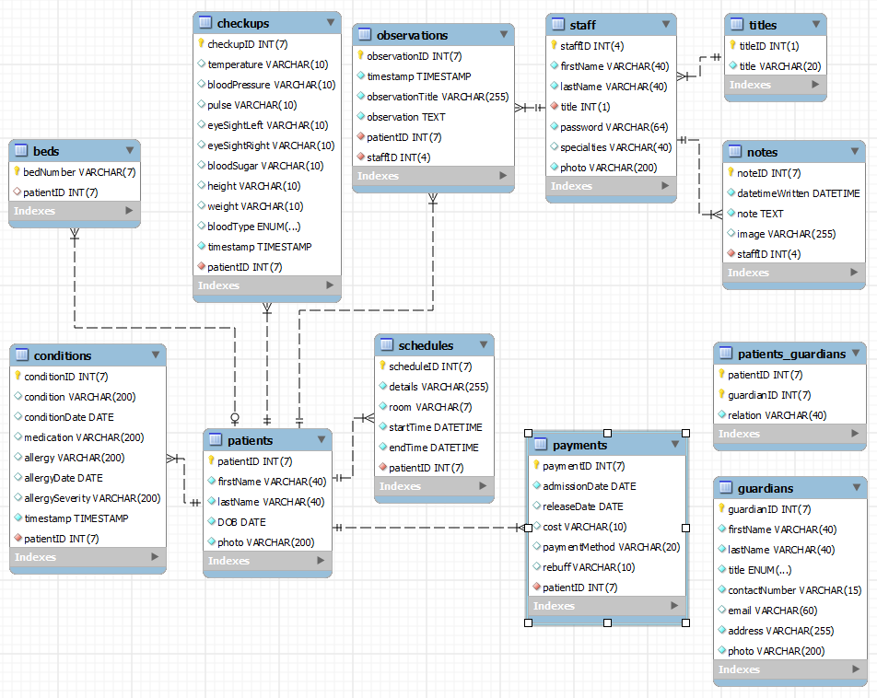

Table 1 - Entity Relationship Diagram

The table names and general descriptions are as follows.

|  |  |
| --- | --- |
| Table Name | Description |
| beds | Used for assigning patients to beds/rooms |
| checkups | Keeps track of various medical measurements of patients |
| conditions | Used to note conditions and allergies of patients |
| guardians | Holds information about patients’ parents/guardians |
| notes | Used by staff to keep notes |
| observations | Used by Nurses to make observations about patients |
| patients | Holds information about patients |
| patients_guardians | Links patients and guardians with what relation they have |
| payments | Used to keep track of a patient’s stay and their payment amounts/methods |
| schedules | Used to schedule patients to hospital resources |
| staff | Holds information about hospital staff |
| titles | Used to save database space by holding the full name of staff titles |

Table 2 - Database tables and descriptions

# 6. Code Quality Assurance

When possible the coding standards which were adhered to during the development of the Townsville Children’s hospital intranet and PRS were as follows.

|  |  |
| --- | --- |
| Technology | Code Stantard |
| HTML | HTML 5 |
| CSS | CSS3 |
| PHP | PHP 5.5.9 / phpMyAdmin 4.1.6 |
| JavaScript | jQuery 1.11.0 / jsPDF |
| XAMPP | 1.8.3 |

Table 3 - Coding standards

In the interest of functionality these standards were not followed exactly in all instances.

# 7. Acceptance Test Plans

The Townsville Children’s Hospital intranet and PRS were tested throughout the project with the use of GitHub. GitHub allowed the system to be tested continually in a simulated live environment, with all developers requiring to comment on all updates to the code repository before uploading. Text editor programs such as Notepad++ and Sublime Text 2 were also extensively used as development tools as well as automatically detecting syntax errors and other easily missed, common coding errors.

Manual testing was mainly used within the website, as most PHP errors that would occur (such as not filling in forms correctly) would already be caught by the code itself and produce corresponding error messages. These consisted of pretty much going through each page with each role, checking that:

1. The form worked as intended when fully filled out
2. The form either didn’t submit or had an appropriate message when attempting to submit a form without filling all of the required fields
3. Non-required fields that were left blank were handled correctly
4. An appropriate message was shown if the user attempted to enter invalid data into the form

There were some errors that occurred during the demonstration, but they were small bugs within the code that were fixed right afterwards.

Known errors/issues remaining in the final system:

* When using “Admit Existing Patient”, if a patient registered in the database had been admitted and discharged in the past, then readmitted again, there is an issue where receptionists are able to continue readmitting that patient over and over as the entry in the form for readmission still displays their name when it shouldn’t.

# 8. Operations Documentation

# 8.1. Installation instructions

1. Install XAMPP (this project was created using version 1.8.3, but later versions may still work); the installation file is located on the USB (if for some reason it isn’t, or the file doesn’t work, you can get it at <https://www.apachefriends.org/download.html>)
2. Copy-paste the “INB201” folder into C:\xampp\htdocs (or the htdocs folder to wherever you chose to install XAMPP)
3. Start up the XAMPP Control Panel and activate/start both the Apache and MySQL modules
4. Click the “Admin” button (next to Start/Stop) for the MySQL module (or type localhost/phpmyadmin into your browser’s address bar)
5. Click the “Import” option on the top bar of the phpMyAdmin interface
6. In “File to Import”, click the “Browse” button where it says “Browse your computer:” and find the database’s .sql file (available on the USB as hospital.sql), leave all other options as-is and click “Go” at the bottom of the page
7. If the database imports correctly, type “localhost/INB201” into the browser’s address bar to access the site
8. Each different role has different functions on the site; the following are the login details for each (written as Role: Username – Password):
   1. Doctor: 0001 – doctor
   2. Nurse: 0003 – nurse
   3. Receptionist: 0004 – receptionist
   4. Administrator: 0005 – administrator

# 8.2. Backup Procedures (Database)

1. Go to phpMyAdmin (localhost/phpmyadmin)
2. Click the “Export” option on the top bar of the interface
3. Where it says “Export method:” click “Custom”
4. Where it says “Database(s):” click only the “hospital” database
5. In “Output:” where it says “File name template:” change this from “@SERVER@” to “hospital” (include the date or some other identifier if needed)
6. Scroll down to the “Object creation options” heading and click on the checkbox for “Add CREATE DATABASE / USE statement”
7. Scroll down to the bottom and click “Go”
8. Save the .sql file in a secure place

# 9. User Guides

# 9.1. Doctor User Guide

1. When you open the homepage for the Townsville Community Hospital intranet you will be greeted with the login screen. Simply enter your current User ID and Password then left-click on the green ‘login’ button.



Figure 9 - Login screen

1. Now that you are logged into the system you can choose from either the left hand menu on the side or pick one of the ‘Dashboard’ links. As a doctor you have access to the functionality of ‘Doctor’s Notes’, Patient Histories’, Nurses’ Observations’, ‘ Upcoming Surgeries’, ‘Schedules’ and ‘Prescriptions’.

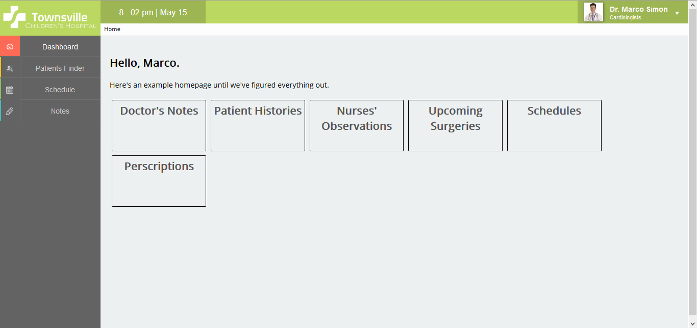

Figure 10 - Doctor dashboard

1. To search the database for a specific patient click on ‘Patient Finder” on the left hand menu. The screen that appears should be the same as below. You can go back at any time by clicking on ‘Home’ underneath the current date and time or by clicking on the ‘Dashboard’ menu item in the left hand menu.  
     
   In this screen you can do a simple search for patients by either patient ID or their name. You can also search using other criteria by choosing from the dropdown menu under ‘Advanced Search’. To the right of this you’ll see a ‘Top 10’ of the ten most recently added patients to the database. This allows easy access to new patients to the Townsville Community Hospital.

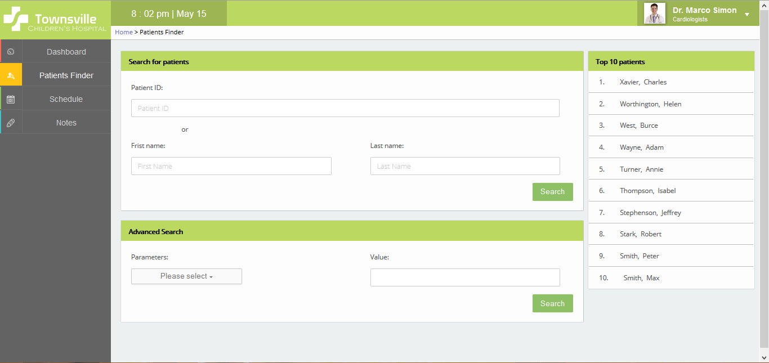

Figure 11 - Patient finder screen

1. After you enter the patient ID or name you will be taken to the record for that patient. In this screen you can see the patient’s personal information. This includes things like their first name, last name, parent or guardian contact information, any allergies and their most recent condition. This screen also allows for exporting to PDF in the case of a transfer to a different hospital and the option to update the details.

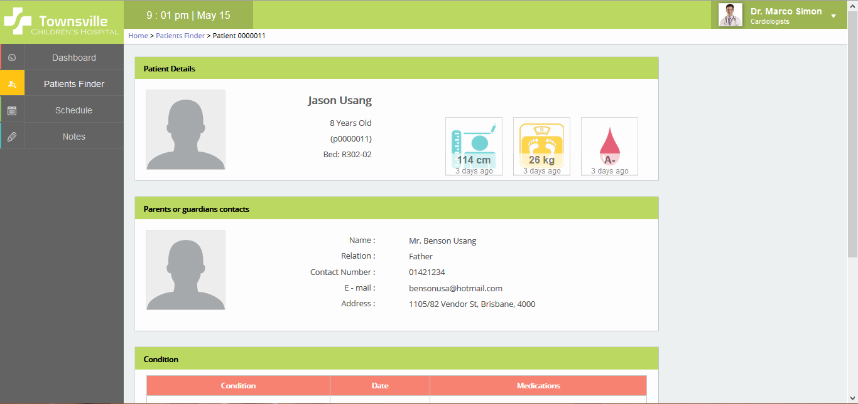

Figure 12 - Patient record scren

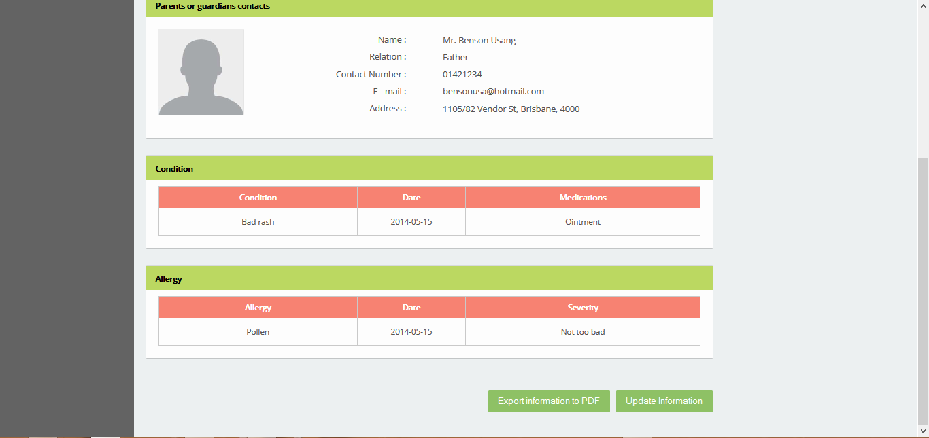

Figure 13 - Patient record screen continued

1. To add a new note click on the menu item ‘Notes’ under the left hand menu. This will take you to the notes page where you can see the patient who has the most recently added note, as well are write new notes. This makes it easier to review patient records which you are currently working on.

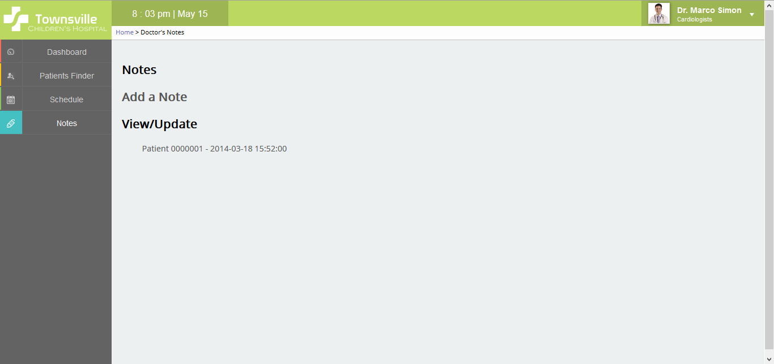

Figure 14 - Add note screen

1. When you are finished reviewing patient records you can click on the arrow in the top right corner and choose ‘Logout’. This menu also allows you to view your staff profile.  
   In your staff profile page you can check that your name is correct as well as your job title. You can also change your password as required.

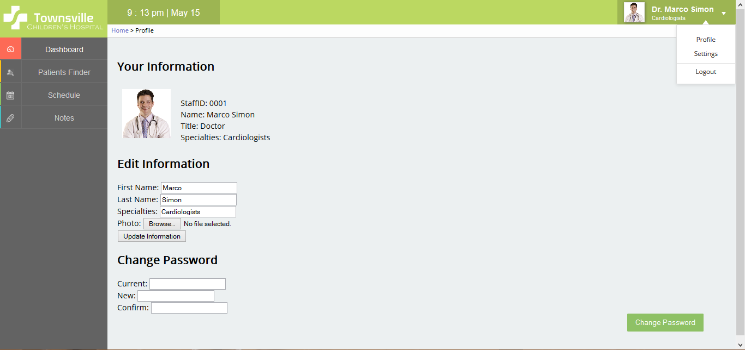

Figure 15 - Staff profile screen

# 9.2. Receptionist User Guide

1. When you open the homepage for the Townsville Community Hospital intranet you will be greeted with the login screen. Simply enter your current User ID and Password then left-click on the green ‘login’ button. Refer to Figure 9, page 11.
2. Now that you are logged into the system you can choose from either the left hand menu on the side or pick one of the ‘Dashboard’ links. As a receptionist you have access to the functionality of ‘Add a Patient’, ‘Update Patient Information’, Assign Bed’, Schedules’ and ‘Export to PDF’.

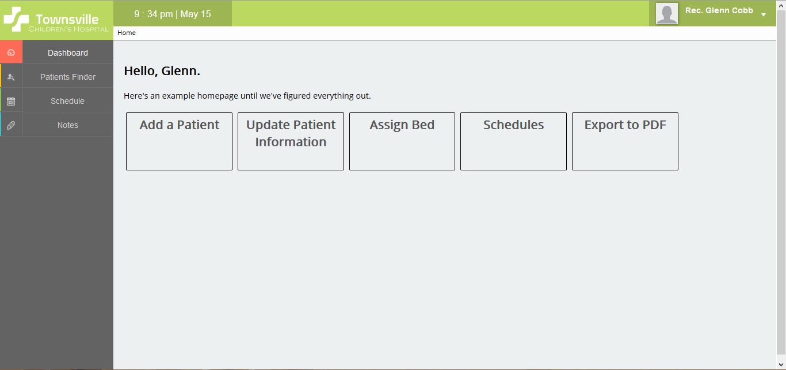

Figure 16 - Receptionist dashboard

1. When a new patient is admitted to the hospital a new patient record is required. To do this click on ‘Add a Patient’ from the initial screen. This will take you to the below webpage. When the patient has finished filling out the necessary forms make sure to enter the information into the necessary fields. These include their first name, last name, data of birth and blood type. Since this is a new patient there will be no notes. Left click on ‘Add Information to Database’ when you are finished.

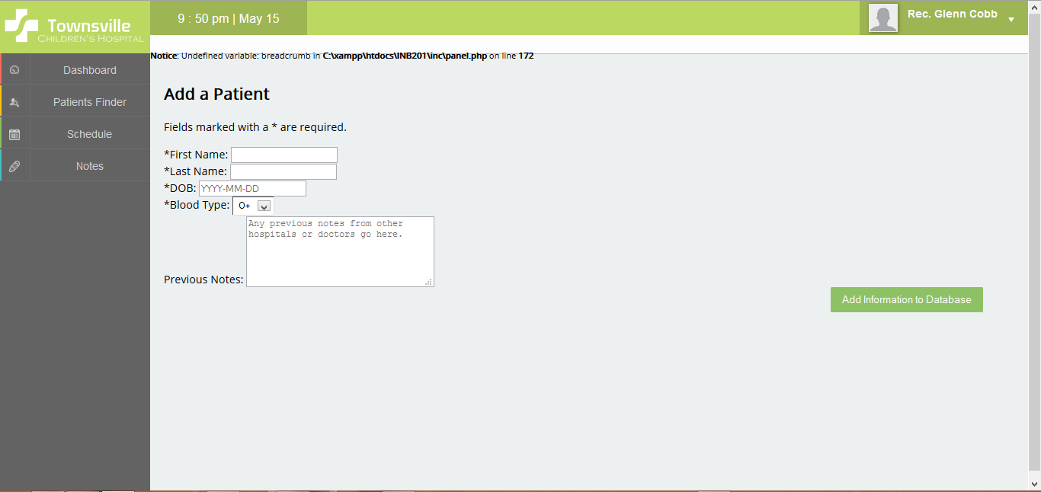

Figure 17 - Add new patient screen

1. To check that you have entered the information correctly or update other patient files click on ‘Dashboard’ at the top of left hand menu. This will take you to first initial webpage from step 1. Click on ‘Update Patent Information’ and you will see the patient list in alphanumeric order by last name.

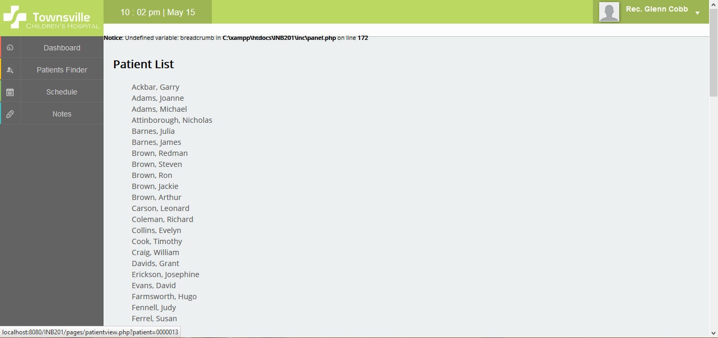

Figure 18 - Patient list screen

1. Now that we have the patient record available choose the patient whose record you need to check or update. Click on their name and you will be taken to the following screen. Refer to figures 12 and 13, page 13.
2. By clicking on ‘Update Information’ you will be taken to the below screen. Here you are able to change things like first name, last name, date of birth as well similar information relating to the patient’s parent or guardian.

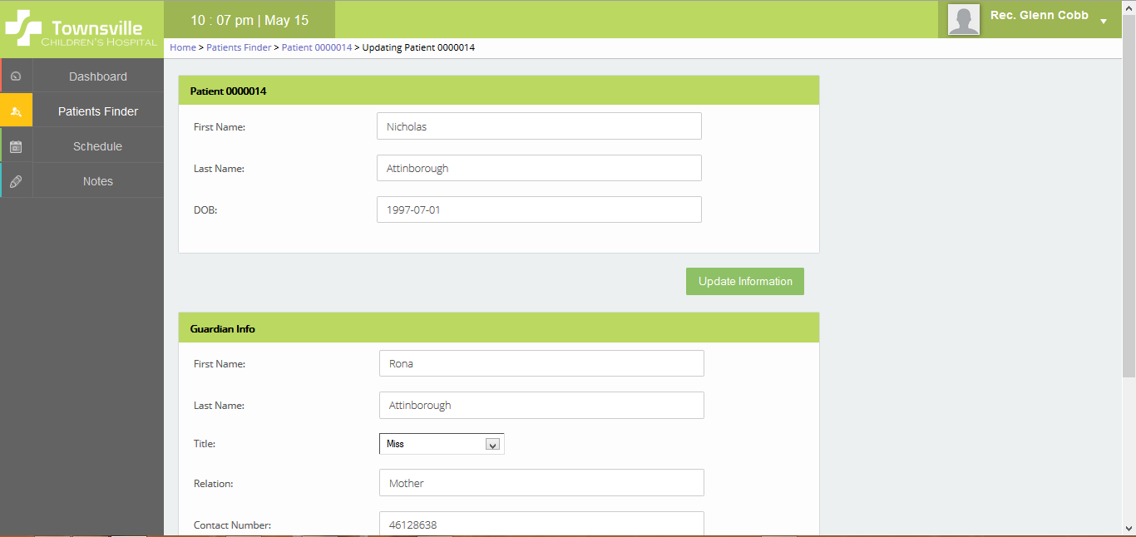

Figure 19 - Update patient information screen

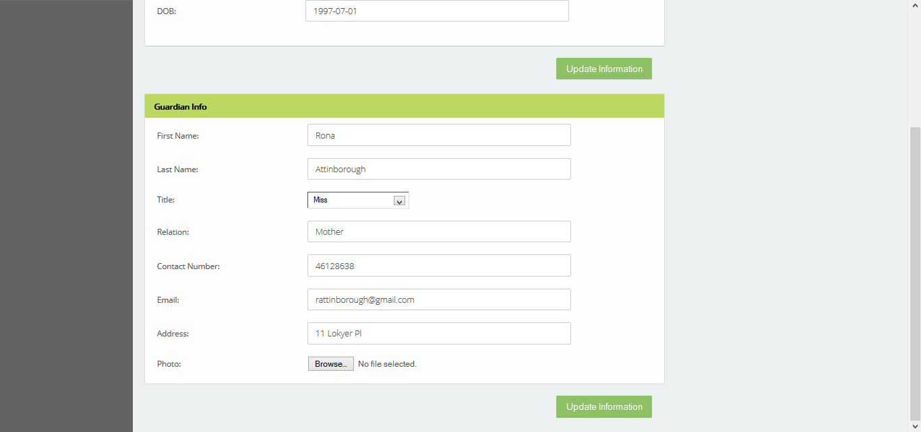

Figure 20 - Update patient information screen continued

1. When you are finished reviewing patient information click on the top right hand dropdown menu and choose ‘logout’. This menu also enables you to view your staff details and change your password as needed. Refer to figure 15, page 14.

# 9.3. Administrator User Guide

1. When you open the homepage for the Townsville Community Hospital intranet you will be greeted with the login screen. Simply enter your current User ID and Password then left-click on the green ‘login’ button. Refer to Figure 9, page 11.
2. Now that you are logged in to the system you will see all the aspects which you are empowered to alter. As the system administrator you have the highest level of clearance and can delete, edit and create records for staff member as well as patient.

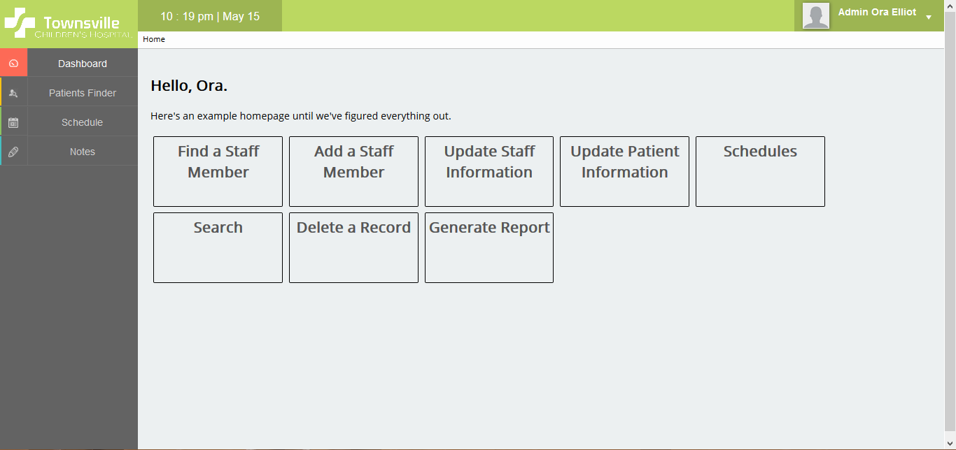

Figure 21 - Administrator dashboard

1. To find and review a staff member’s information left click on ‘Find a Staff Member’. The below screen will load. If you know the staff ID type in this otherwise enter the name or search by job title. Click on ‘Search’ when this is completed.

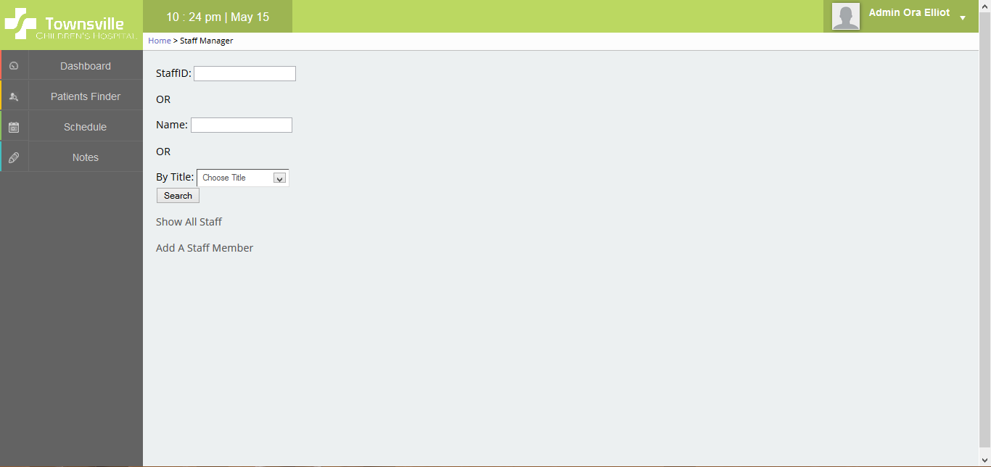

Figure 22 - Staff manager screen

1. For example we have searched by the staff ID ‘0001’. This is for Doctor Marco Simon. You are now able to review his name, title and specialisations. Click on ‘Update Information’ when the necessary adjustments have been made.

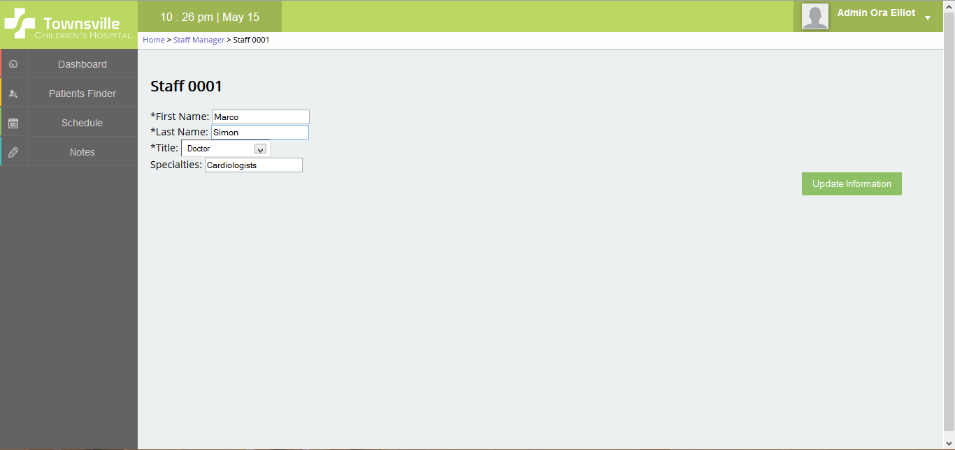

Figure 23 - Edit staff record screen

1. When you are finished deleting, editing and creating patient and staff member records click on the top right hand dropdown menu and choose ‘Logout’. This dropdown menu also allows you to view your personal details and alter them if necessary. Refer to figure 15, page 14.

# 10. Sprint Backlogs, Burn Down Charts

# 10.1. Sprint 1

For the first sprint the team consisted of Peter Burt, Michael Moss and Andrew Snodgrass. The tasks assigned to each team member were as followed:

* Andrew Snodgrass – Scrum master  
  Noted functional and non-functional requirements for the project. Participated in group discussion. Created the main web pages needed for the client-side intranet with HTML and CSS.
* Peter Burt – Team member  
  Designed and created the server-side database in SQL and assisted in the division of the workload. Contributed to group discussions.
* Michael Moss – Team member  
  Contributed to discussions and helped in the design of the database. Was unable to finish PHP coding as Andrew Snodgrass initially procrastinated in the design of the web pages.
* Yancie Ng – Team member  
  Yancie did not participate in the first sprint.

# 10.2. Sprint 2

A new team member was added during the second sprint, this was Yancie Ng. Yancie redesigned the original HTML and CSS that was created by Andrew Snodgrass. These new web pages incorporated JaveScript, better design and an overall more polished presentation. The tasks that were assigned to each team member are listed in the burn down chart.

* Andrew Snodgrass – Team member  
  Collected and reviewed all available information regarding role based access control for the Townsville Children’s Hospital. This includes information that was generated from group discussion as well as what was provided in the assignment tasksheet and other documentation provided by the lecturer. This was for all necessary user groups, excepting patients. This information and was then assigned to role based access for doctors, nurses, medical technicians, receptionists, hospital / system administrators. This was necessary to help other team members code PHP and re-design the web pages appropriately. Peter Burt was then able to create login accounts for all the user groups, so their access was tied directly to their job requirements and outlines.
* Peter Burt – Scrum master  
  Peter’s areas of responsibility were PHP coding and database functionality. This included generating test data, creating functional PHP login code, creating and testing logins for all user accounts, assisting other team members with their tasks and overseeing all aspects of the sprint itself. Peter also implemented the ability to create, edit and delete database information in the intranet client-side without accessing the database files directly, a specified requirement in the assignment tasksheet. Peter undertook extensive testing so all implemented functionality worked as expected and adjusted code that included PHP, HTML, CSS where it was appropriate.
* Michael Moss – Team member  
  Assisted other team members by fixing bugs in the implemented functionality and provided test data for the system. Michael also assisted other team members when requested.
* Yancie Ng – Team member  
  Yancie did an extensive redesign of the previous web pages created by Andrew Snodgrass. She redid the initial login web page and also improved the overall layout and design of the website elements. Yancie added new image assets and added subtle animations to improve user friendliness and create a consistent design language. She also altered associated PHP and database items so everything worked together seamlessly.

# 10.3. Sprint 3

The third sprint was undertaken during the midsemester break. This one week was ignored and not taken into account during the sprint. During this spring problems were encountered which impacted on the workflow. This is as follows:

* Andrew Snodgrass – Team member  
  Andrew Snodgrass was tasked with taking the design for the Patient Finder and Patient Record web pages and turning them into HTML and CSS. Yancie Ng had created these designs in Photoshop. Andrew was only able to complete the HTML and CSS for the Patient Finder page as he is not as skilled in HTML, CSS and JavaScript as Yancie. Unfortunately Yancie was not available for assistance as she was out of the country at the time. Other team members were unable to assist as well.
* Peter Burt – Team member  
  Continued with coding necessary PHP for the purpose of functionality. Peter developed the database further and merged the content Andrew Snodgrass has designed for the Patient Finder web page into the official GitHub repository.
* Michael Moss – Scrum Master  
  Added more data to the database for testing purposes.
* Yancie Ng – Team member  
  Designed the PRS layout in Photoshop for Andrew Snodgrass to use as a template.





# 10.4. Sprint 4

Further PHP functionality needed to be coded. Yancie Ng finished the HTML, CSS and JavaScript for PRS web pages that Andrew Snodgrass was unable to complete. The tasks assigned to each team member were as followed:

* Andrew Snodgrass – Team member  
  Andrew volunteered to do the user guides for the required documentation. This was completed although he used too many screenshots and later fixed this in the final sprint, sprint 5.
* Peter Burt – Team member  
  Finished coding necessary PHP functions for the functionality of the Townsville Children’s Hospital intranet, server side. He also maintained and added more necessary databases as required to support client needs. Merged the PHP with the HTML and CSS files as well.
* Michael Moss – Team member  
  Added more data to the database for testing purposes.
* Yancie Ng – Scrum Master  
  Completed the patient record system’s HTML, CSS and JavaScript so it was functional and mostly complete.

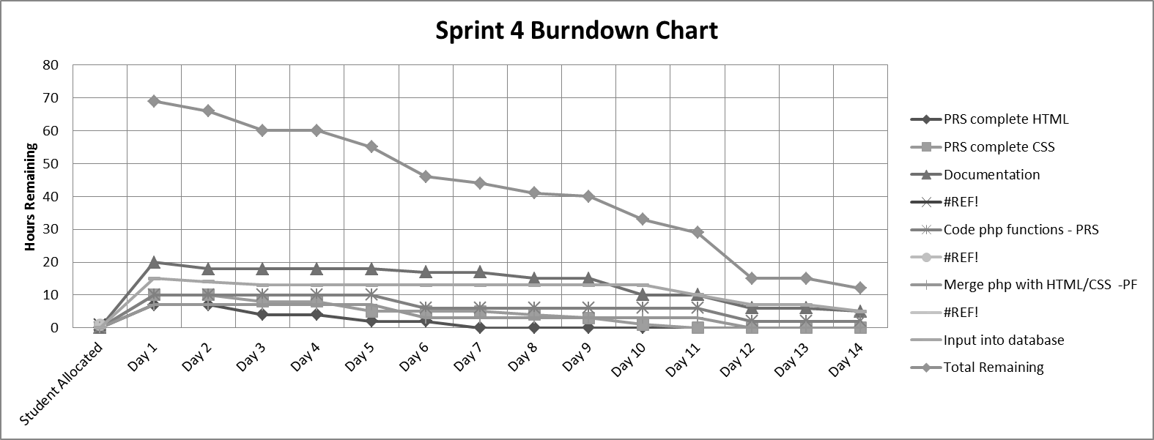

# 10.5. Sprint 5

For the first sprint the team consisted of Peter Burt, Michael Moss and Andrew Snodgrass. The tasks assigned to each team member were as followed:

* Andrew Snodgrass – Scrum master  
  Andrew Snodgrass was tasked with completing the rest of the required documentation as this was the final sprint and it needed to be finished. The team has mostly focused on technical aspects of the project until now. This wasn’t completed but many notes were collected from documents that had been generated during the previous sprints. The document was uploaded to GitHub to encourage team members to add or change aspects they were responsible for.
* Peter Burt – Team member  
  Continued with coding necessary PHP for the purpose of functionality. Peter developed the database further and merged the content Andrew Snodgrass has designed for the Patient Finder web page into the official GitHub repository.
* Michael Moss – Team member  
  Completed all necessary data sets for the Townsville Childen’s Hospital intranet to function properly. This was sync with all the other data on GitHub and merged when necessary.
* Yancie Ng – Team member  
  Further refined the HTML, JavaScript & other web elements for the client side intranet. Created new pages for things we haven’t finished yet or gotten to previously.

